Nama : Siti Sa’adah
NIM : 2403001
Kelas : D3 TI 2A
Mata Kuliah : Internet Of Thinks

TUGAS PRAKTIKUM

MENGHUBUNGKAN ANTARA SERVER DENGAN MYSQL

Buka teks editor VSCode, buat project (folder) dengan nama ‘data_ingestion’. Buat file dengan nama ‘requirements.txt’. Isi seperti pada gambar.
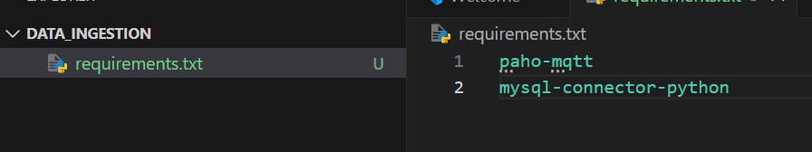
- Install pakage yang telah di masukan ke dalam file
Install satu persatu
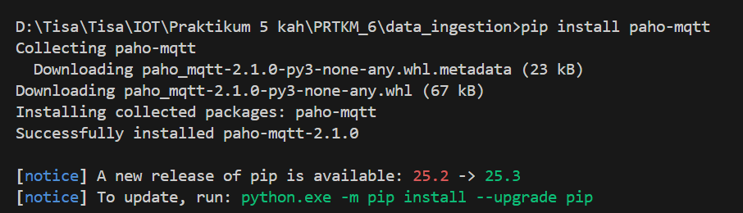
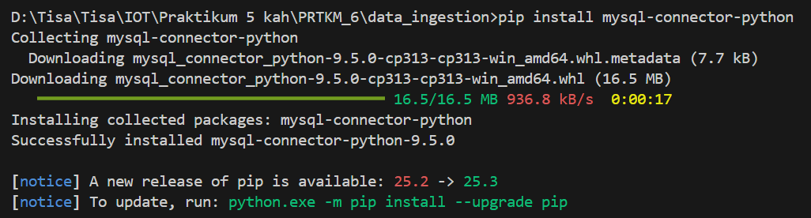

Install satu kali
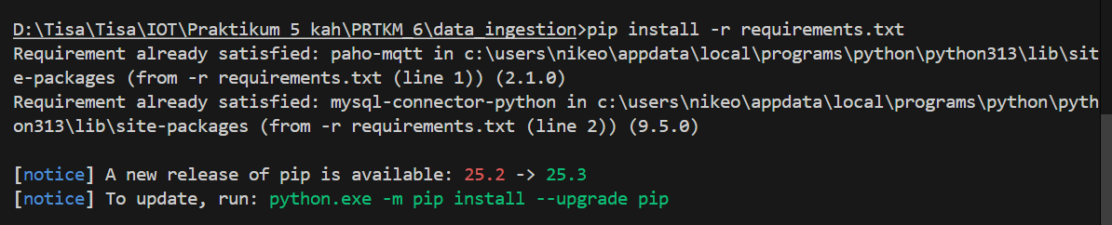
- Buat file baru dengan nama ‘koneksi.py’. Isi dengan kode program berikut
import mysql.connector

# Connect to server
cnx = mysql.connector.connect(
host="127.0.0.1",
port=3306,
user="root",
password="")

# Get a cursor
cur = cnx.cursor()

# Execute a query
cur.execute("SELECT CURDATE()")

# Fetch one result
row = cur.fetchone()
print("Current date is: {0}".format(row[0]))

# Close connection
cnx.close()

- Run koneksi.py
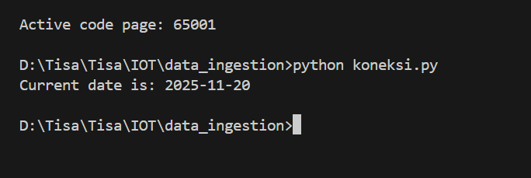

- Buat database baru di localhost, buat table baru dengan nama ‘sensor’ (namun typo pada penulisan, jadi nama table nya ‘sersor’).
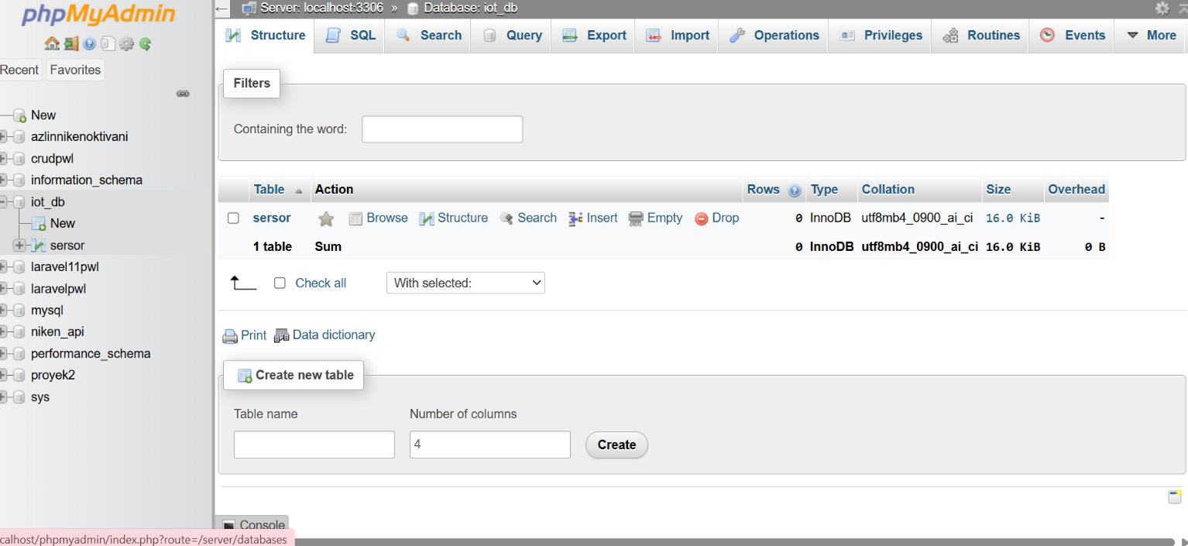
- Isi struktur table.
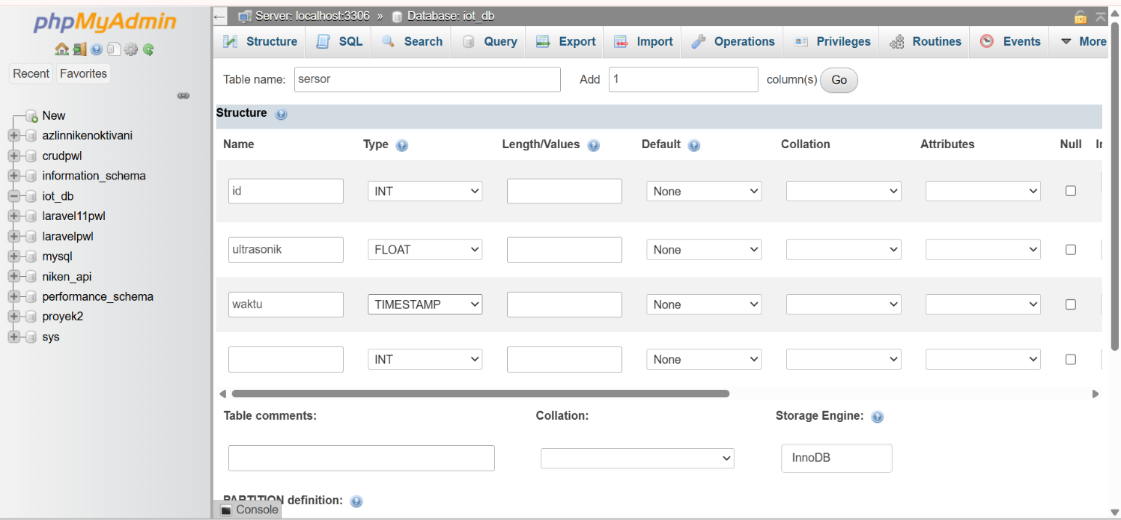

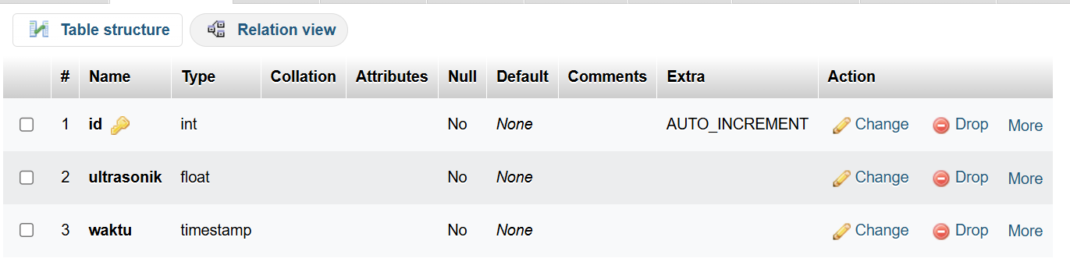
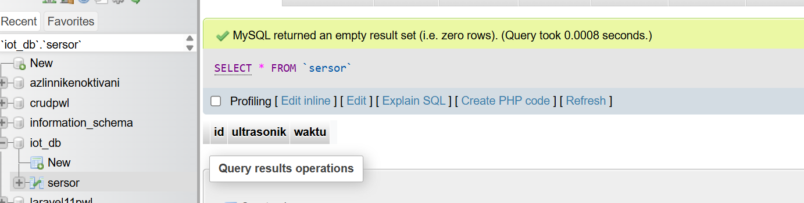
- Ubah kode program koneksi.py menjadi seperti berikut
import mysql.connector
# Connect to server
cnx = mysql.connector.connect(
host="127.0.0.1",
port=3306,
user="root",
password="",
database='iot_db')

# Get a cursor
cur = cnx.cursor()

# Execute a query
# cur.execute("SELECT CURDATE()")
# Fetch one result
# row = cur.fetchone()
# print("Current date is: {0}".format(row[0]))

tesTambahData = "INSERT INTO sersor (ultrasonik, waktu) VALUES (%s, NOW())"
#tesTambahData = ("INSERT INTO sensor " "(ultrasonik)" "VALUES (%s)")
data_ultrasonik = ("100",)
cur.execute(tesTambahData, data_ultrasonik)
cnx.commit()
cur.close()

# Close connection
cnx.close()

- Run koneksi.py
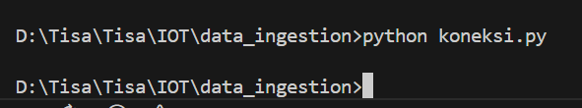
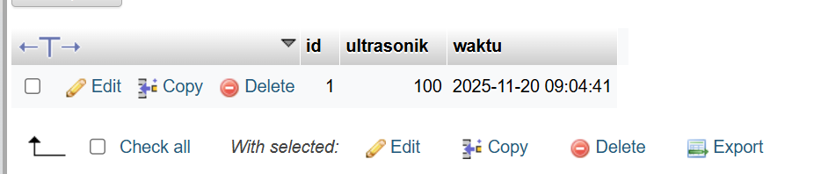
- Buat file baru ‘mqtt.py’
import paho.mqtt.client as mqtt

# The callback for when the client receives a CONNACK response from the server.
def on_connect(client, userdata, flags, reason_code, properties):
print(f"Connected with result code {reason_code}")
# Subscribing in on_connect() means that if we lose the connection and
# reconnect then subscriptions will be renewed.
client.subscribe("polindra/iot")

# The callback for when a PUBLISH message is received from the server.
def on_message(client, userdata, msg):
print(msg.topic+" "+str(msg.payload)) #pesan yang keluar di terminal itu dari kodingan ini

mqttc = mqtt.Client(mqtt.CallbackAPIVersion.VERSION2)
mqttc.on_connect = on_connect
mqttc.on_message = on_message

mqttc.connect("broker.hivemq.com", 1883, 60)

# Blocking call that processes network traffic, dispatches callbacks and
# handles reconnecting.
# Other loop*() functions are available that give a threaded interface and a
# manual interface.
mqttc.loop_forever()

- Hubungkan dengan mqtt.broker sesuaikan subcribe & topik nya.
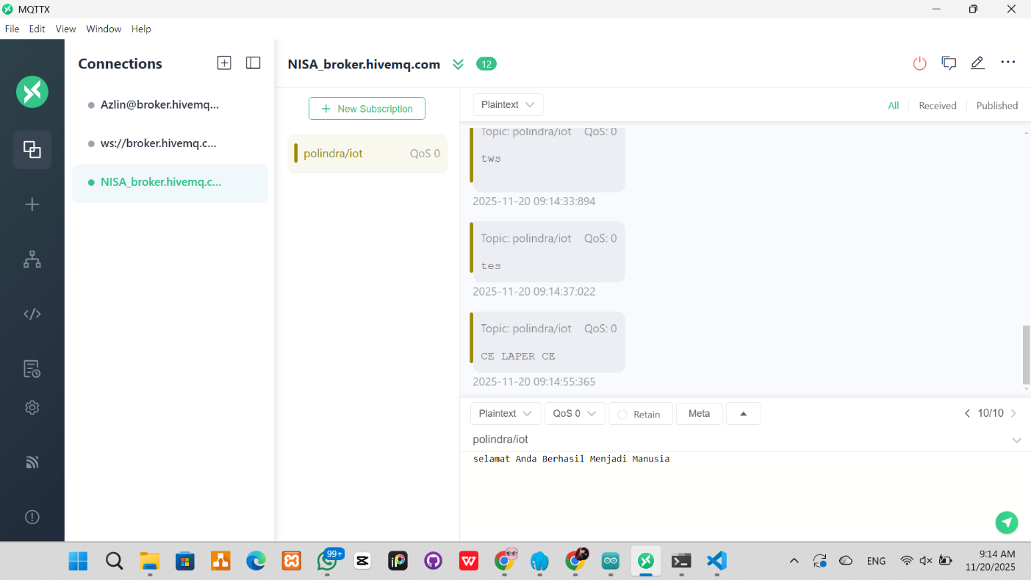
- Buka terminal di VSCode, cek apakah terhubung. Jika terhubung maka data akan masuk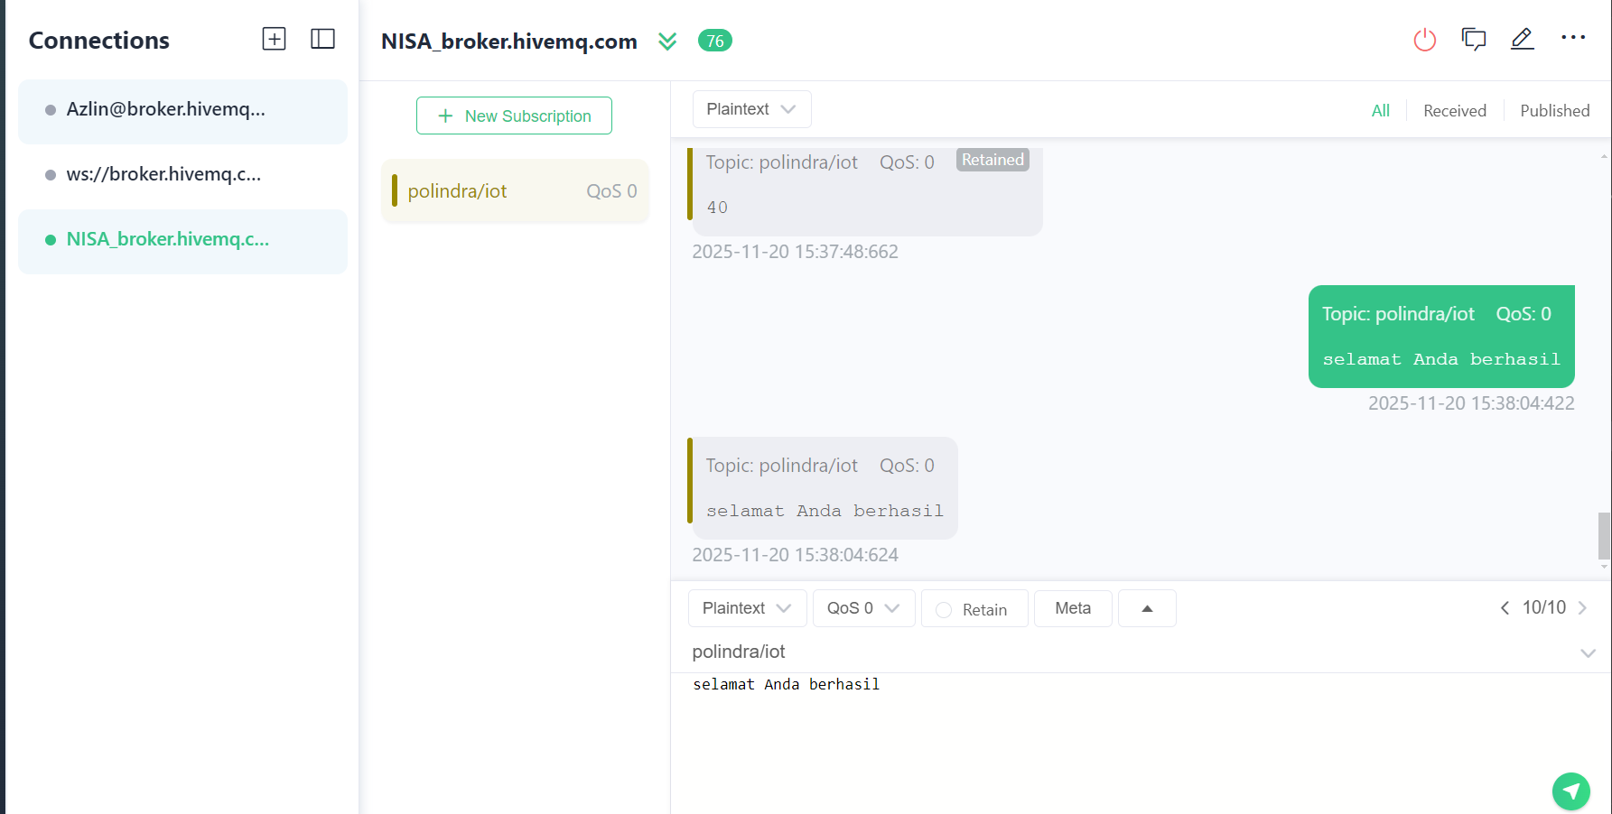
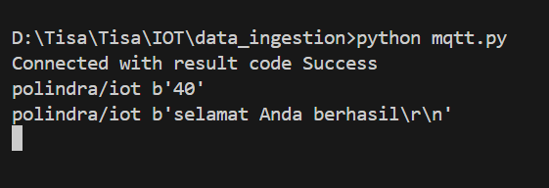

- Buat file baru dengan nama ‘gabung.py’ (menghubungkan mqtt dan database, hingga menjadi realtime)
import mysql.connector
import paho.mqtt.client as mqtt

cnx = mysql.connector.connect(
host="127.0.0.1",
port=3306,
user="root",
password="",
database='iot_db'
)
cur = cnx.cursor()

# Query insert
query_insert = "INSERT INTO sersor (ultrasonik, waktu) VALUES (%s, NOW())"

def on_connect(client, userdata, flags, reason_code, properties):
print(f"Connected with result code {reason_code}")
client.subscribe("polindra/iot/ultrasonic")

def on_message(client, userdata, msg):
payload = msg.payload.decode()

print(f"{msg.topic} : {payload}")

# Insert ke database setiap ada pesan baru
try:
cur.execute(query_insert, (payload,))
cnx.commit()
print("Data disimpan ke database.")
except Exception as e:
print("Gagal insert:", e)
mqttc = mqtt.Client(mqtt.CallbackAPIVersion.VERSION2)
mqttc.on_connect = on_connect
mqttc.on_message = on_message

mqttc.connect("broker.hivemq.com", 1883, 60)

mqttc.loop_forever()

- Coba kirimkan data di mqtt, buka teminal jika masuk maka berhasil terhubung.
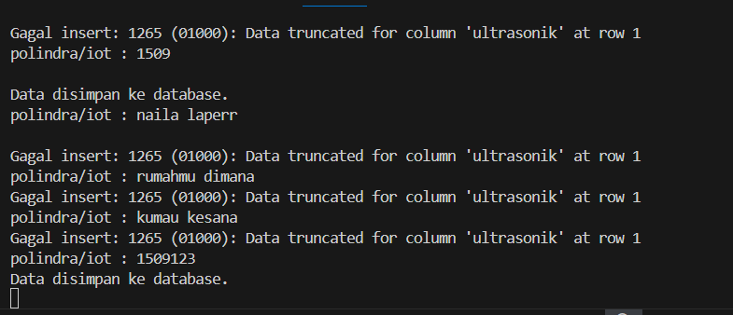
- Buka database yang telah dibuat, cek apakah data nya sudah masuk
